Southern Cloud Summer School

Glasco/Miltonvale

“Exploring Jobs Around Us” was the theme of summer school 2024. Eighteen students were in attendance throughout the month of June brushing up on reading and math skills. They were also able to participate in the summer reading program at the Glasco Library, RVED classes on self-affirmation and robotics, and take two fieldtrips. They visited the Clay County Sheriff’s Department where they toured the office and jail facilities. They took a trip to Concordia where they toured SUBWAY and CCCC to learn about renewable energy careers. Thank you to everyone who helped facilitate these activities and to the parents and students for their part in being at summer school. Maybe someday these jobs around us will be filled by one of these students.

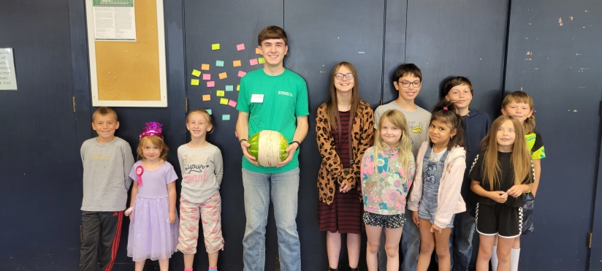

River Valley Extension District summer educator Bricen Benyshek taught lessons on self-affirmation and robotics at SC Summer School.

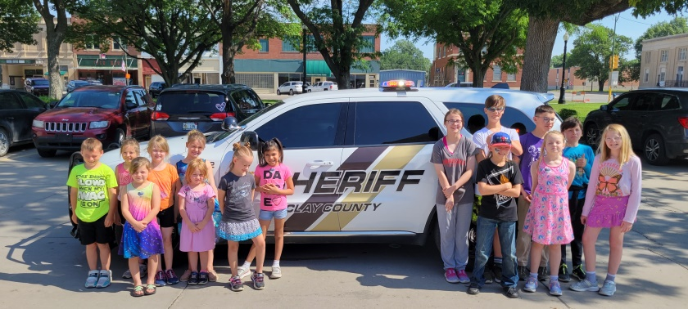

SC Summer School students visit Clay County Sheriff Dept. tour led by Officer Primeaux.

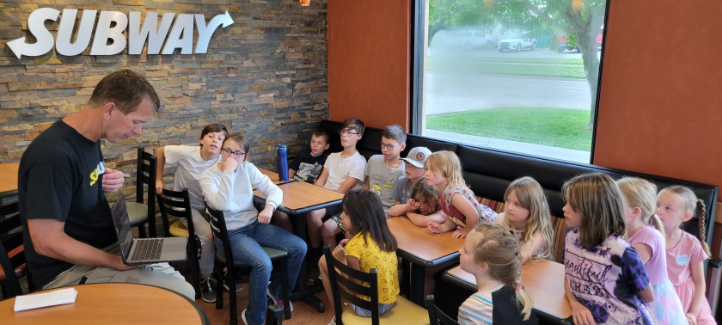

Learning about the workings of SUBWAY and enjoying some samples. Thanks Mr. Hoffman and Crystal.